**Implementing a computer network**

**for Ceplenița village**

**-client and area description file-**

**1.Objective**

The objective of this paper is to describe the area and its parameters favorable for implementing a computer system network.

**2.Describing our company**

Our company named S.C. CNforall S.R.L. is a professional one, with its area of expertise being that of analyzing the possibility and implementing computer networks for small clients(such as companies) to big ones( such as villages and small cities) while ensuring the best quality possible. Taking into account the needs and feedback of our clients are ones of our top priorities!

**3.Describing the client**

The client is the Ceplenița Village Hall.

Ceplenița is a village situated in Iași county with a population of 425 habitants and the administrative center of more appended villages that are Buhalnița( 1686 population situated 3km from the commune), Poiana marului (1067 population ,5 km west of the commune), Zlodica( 339 population, 3km S-E).

Our services could target a total number of 3517 households and a considerable number of public institutions such as the Ceplenița City Hall, Ceplenița Public Library( which has over 700 frequent readers), 4 schools, 4 kindergartens, one police station and more than 10 private companies.

The increasing number of cultural and educational public events that could use the computer network fiber lines for broadcast across the internet represent another potential client.

Cameras used for surveillance installed on public properties (such as the Ceplenița Public Park) could also wire up to the computer network.

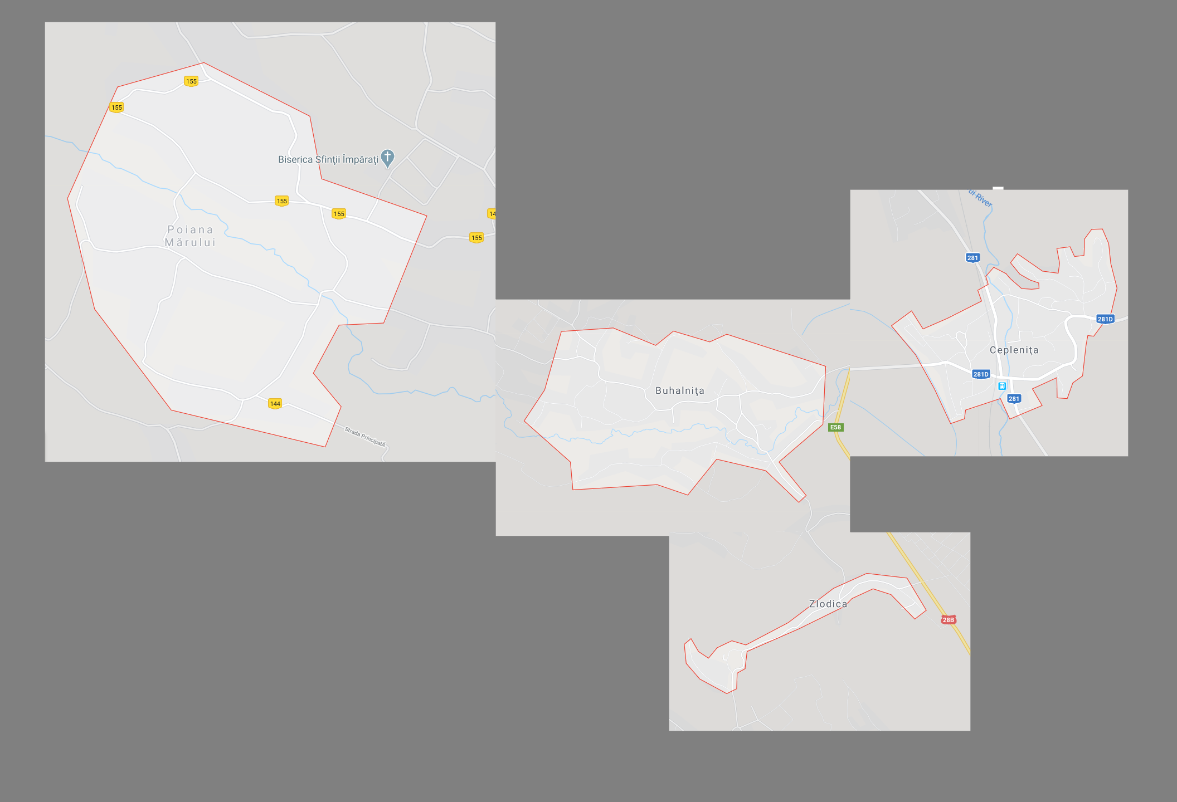

**4.Additional parameters**

The big distance between the villages in the commune makes it more difficult(cost wise) in establishing the project. This drawback, however is ameliorated by the big number of individual network users.

The positive feedback received through our recent survey showed us that more than 90% of the total population would be willing to benefit from the computer network service.

An already existing,unused telephone line covering 30% of potential clients which could save up the costs.

The major increase in population in the past years and modern life necessities that target the access to digital information at high speed.

**5.Conclusion**

Taking into consideration the client, the area and the additional parameters that characterizes them we, S.C. CNforall S.R.L. have come to the conclusion that the project is within our area of realisation and have agreed to work on it.